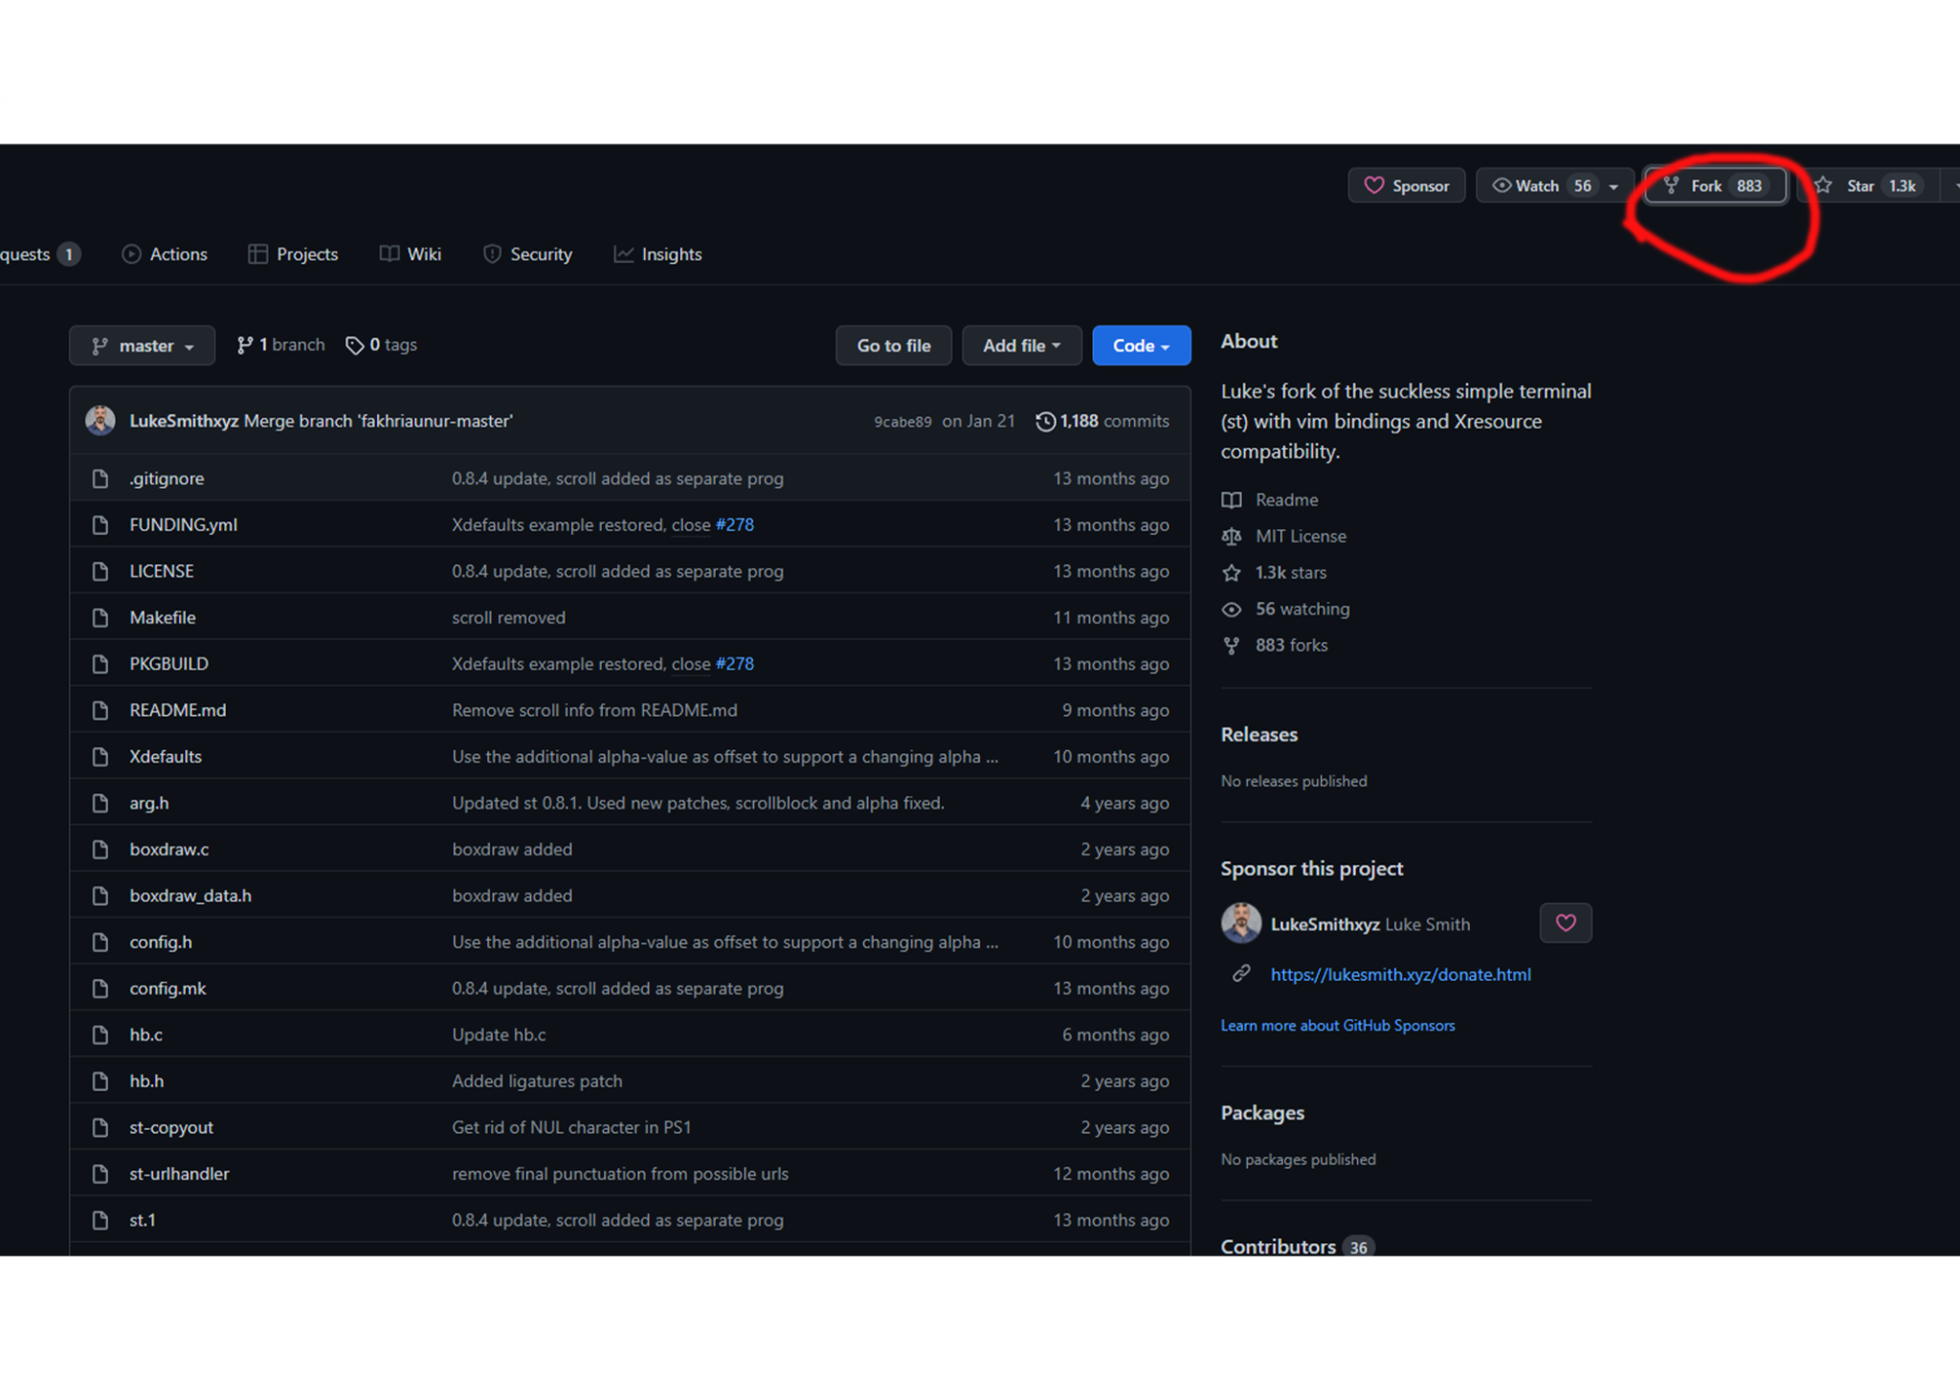

1. Navigate to the Github website
2. Enter a repository
3. At the top right is the fork icon, click that and Github does the rest

* A fork is a copy of a repository that you manage. Forks let you make changes to a project without affecting the original repository. You can fetch updates from or submit changes to the original repository with pull requests.
* Used to either propose changes to someone else’s project or to use someone else’s project as a starting point for your own idea